Person writing press release | Insert date
Internal approval | Insert date
External Approval | Insert date
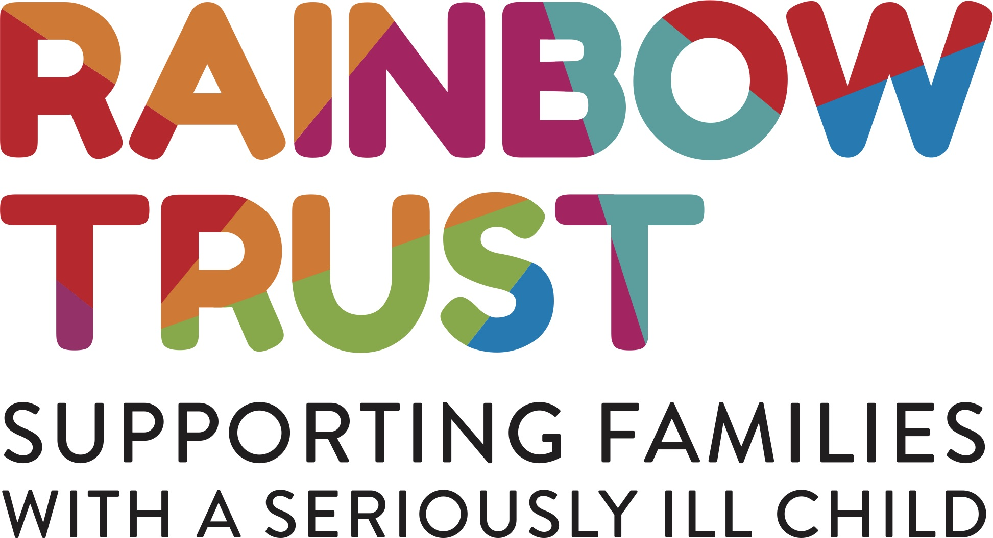

Local [man/woman/teen] from [location] is taking part in [name of event] to raise money for Rainbow Trust Children’s Charity

[Place image of fundraiser during training here - ideally with Rainbow Trust logo visible]

[Insert name], from [insert location] is taking part in the [name of event] on [insert date] to raise money for Rainbow Trust Children’s Charity,

[Insert name] is aiming to complete the [name of challenge e.g. half marathon] in [insert time] and hopes to raise as much money as possible for Rainbow Trust. [He/she] says: “Despite the challenge, completing the [insert name of event] will be such an achievement for me and knowing what I raise will be going to such a great cause, makes it all worthwhile.”

Rainbow Trust enables families who have a child with a life threatening illness to make the most of their time together. Rainbow Trust pairs each family with an expert Family Support Worker who helps them at home, in hospital and in the community, for as long as it is needed.

Oonagh Goodman, Director of Fundraising and Marketing at Rainbow Trust, says: “It’s down to the generosity of our supporters that we are able to continue raising vital funds to support families in need. We’d like to thank all our runners, like [insert name], for helping us raise awareness of the work Rainbow Trust does.”

To sponsor [insert name], visit [his/her] JustGiving page online: [insert website URL]

- Ends -

PHOTO NOTES:
Photo 1 (L-R): [Insert name(s) of people in the above image from left to right, where it was taken and what they’re doing]

NOTES TO EDITORS:
Rainbow Trust Children’s Charity:

- When a child has a serious illness, family life is turned upside down and time becomes more precious than ever. Rainbow Trust pairs each family with an expert Family Support Worker to help them at home, in hospital and in the community to make life a little easier
- Family Support Workers enable families to make the most of their time together. They provide practical and emotional support, where families need it, for as long as it is needed. Their support can include:
  - Listening to a family’s fears and anxieties
  - Driving families to hospital appointments and siblings to school
  - Organising fun activities to support brothers and sisters
  - Explaining illnesses, diagnoses and treatments
  - Staying with the seriously ill child during appointments or hospital visits
  - Supporting families with an ill baby on the neonatal unit
  - Bereavement support if a child dies, which might include helping arrange a funeral or visiting the child’s grave with the family
- Rainbow Trust relies almost entirely on voluntary donations and through the generosity of its supporters helped over 2,300 families last year through its nine care teams of Family Support Workers across England
- Rainbow Trust’s vision is that every family in the UK who has a child with a life threatening illness receives the support they need.

For more press information or opportunities please contact:

Anna Jackson – PR Manager
Tel: 01372 220 028
Email: anna.jackson@rainbowtrust.org.uk

Clare Youings – Senior Press Officer
Tel: 01372 220 018
Email: clare.youings@rainbowtrust.org.uk

For Rainbow Trust’s email confidentiality statement please see our cookie and privacy policy.If you wish to unsubscribe from this mailing list please email anna.jackson@rainbowtrust.org.uk

