Person writing press release | Insert date
Internal approval | Insert date
External Approval | Insert date
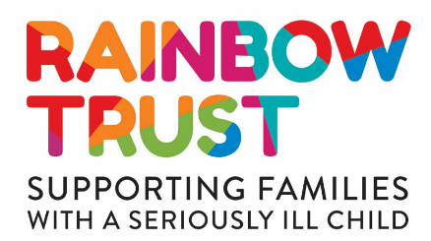

[Location and type of business/school] to hold [type of event] for Rainbow Trust Children’s Charity
[Place image here - ideally with Rainbow Trust logo visible]

The [insert group/business/school name], from [insert location] is holding a [insert type of event] on [insert date] to help raise funds for Rainbow Trust Children’s Charity, which supports families with a seriously ill child.

The event invites [locals/friends/family/customers] to enjoy a fun-filled day including [insert example activities/agenda]. With help from supporters, the [insert group/business/school name] is hoping to raise [insert amount] through [insert raffle/ticket sales etc.].

Rainbow Trust enables families who have a child with a life threatening illness to make the most of their time together. Rainbow Trust pairs each family with an expert Family Support Worker who helps them at home, in hospital and in the community, for as long as it is needed.

Oonagh Goodman, Director of Fundraising and Marketing at Rainbow Trust, says: “We are very grateful that [insert school/business name] is holding such a fantastic event to help us fund our vital support to families with a seriously ill child. It’s going to be a great [night/day]. Money raised from the event will enable families with a seriously ill child to make the most of the precious time they have together.” [or insert suggested quote]

Rainbow Trust is a national charity providing expert practical and emotional support to families, where they need it, to help them make the most of each new day. It relies almost entirely on voluntary donations and thanks to the generosity of its supporters helps over 2,300 families through its nine care teams in England.

- Ends -

PHOTO NOTES:
Photo 1 (L-R): [Insert name(s) of people in the above image from left to right, where it was taken and what they’re doing]

NOTES TO EDITORS:
Rainbow Trust Children’s Charity:

- When a child has a serious illness, family life is turned upside down and time becomes more precious than ever. Rainbow Trust pairs each family with an expert Family Support Worker to help them at home, in hospital and in the community to make life a little easier
- Family Support Workers enable families to make the most of their time together. They provide practical and emotional support, where families need it, for as long as it is needed. Their support can include:
  - Listening to a family’s fears and anxieties
  - Driving families to hospital appointments and siblings to school
  - Organising fun activities to support brothers and sisters
  - Explaining illnesses, diagnoses and treatments
  - Staying with the seriously ill child during appointments or hospital visits
  - Supporting families with an ill baby on the neonatal unit
  - Bereavement support if a child dies, which might include helping arrange a funeral or visiting the child’s grave with the family
- Rainbow Trust relies almost entirely on voluntary donations and through the generosity of its supporters helped over 2,300 families last year through its nine care teams of Family Support Workers across England
- Rainbow Trust’s vision is that every family in the UK who has a child with a life threatening illness receives the support they need.

For more press information or opportunities please contact:

Anna Jackson – PR Manager
Tel: 01372 220 028
Email: anna.jackson@rainbowtrust.org.uk

Clare Youings – Senior Press Officer
Tel: 01372 220 018
Email: clare.youings@rainbowtrust.org.uk

For Rainbow Trust’s email confidentiality statement please see our cookie and privacy policy.If you wish to unsubscribe from this mailing list please email anna.jackson@rainbowtrust.org.uk

